# Project Summary

1.The dashboard (job and shipment trends) is shown below:-

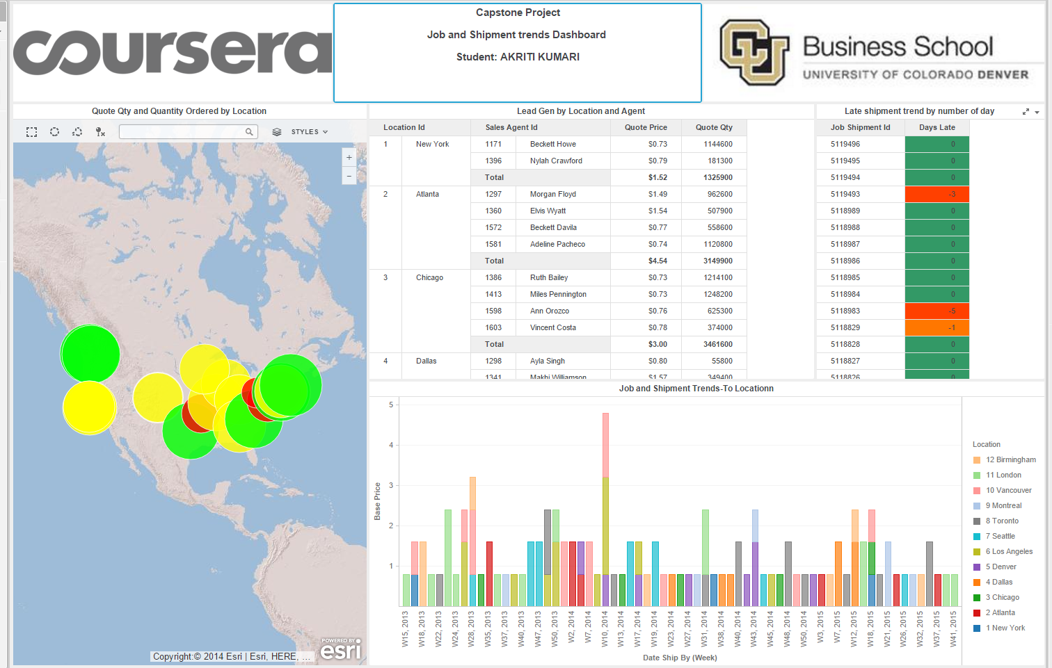

**VISUALIZATIONS**

* Quote quantity and Quantity Ordered by location:- helps to identify the location having the qty ordered high and low and nummber of subjobs at each location.
* Lead generated by location and Agent :- helps to determine sales Agent ,Quotes price and quantity at each location.
* Late shipment by number of days:- helps to identify the delay in shipment.
* Job and Shipment Trends to Location :- helps ti identify difference in base price across location and across cities

2. **Invoice Trends Dashboard** is shown below:-

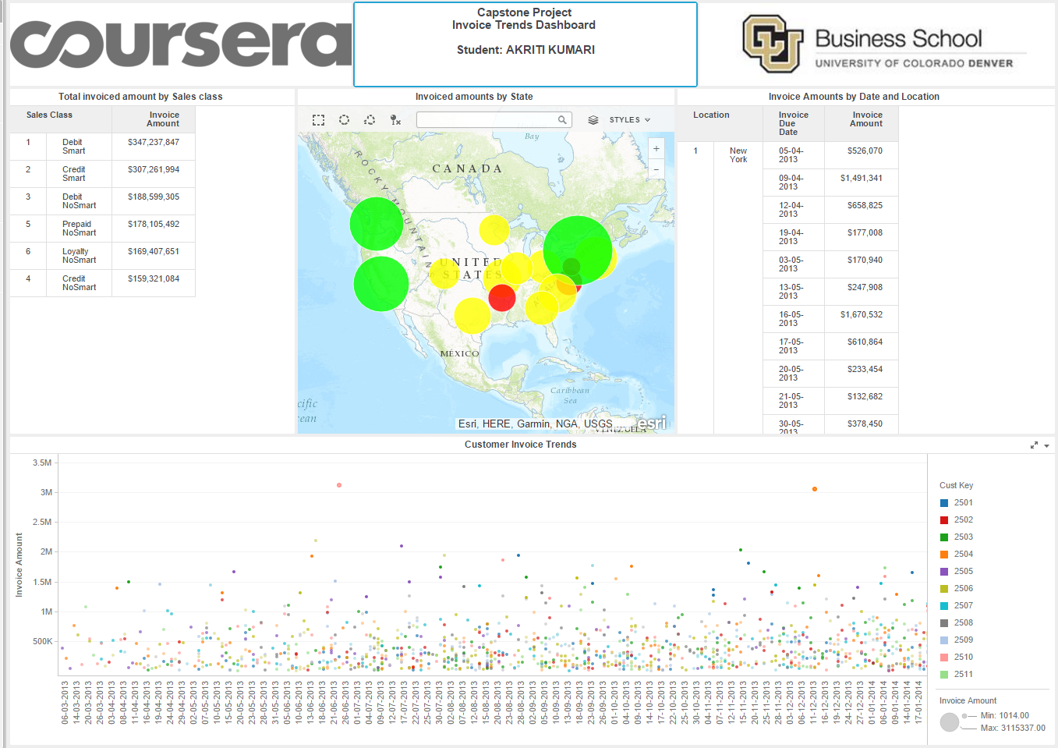

**VISUALIZATIONS**

* Invoice amount by sales class:- helps to identify invoiced amount at each location
* Total invoiced amount by Sales class:- helps to identify invoice amount for each sales class.Debit smart generates highest invoice amount.
* Invoice amount by Date and location :- helps to identify invoice amount and due date for each location.
* Customer Invoice Trends:- helps to identify customer invoice amount for each invoice due dates.

**3. Financal Performance Dashboard** is shown below:-

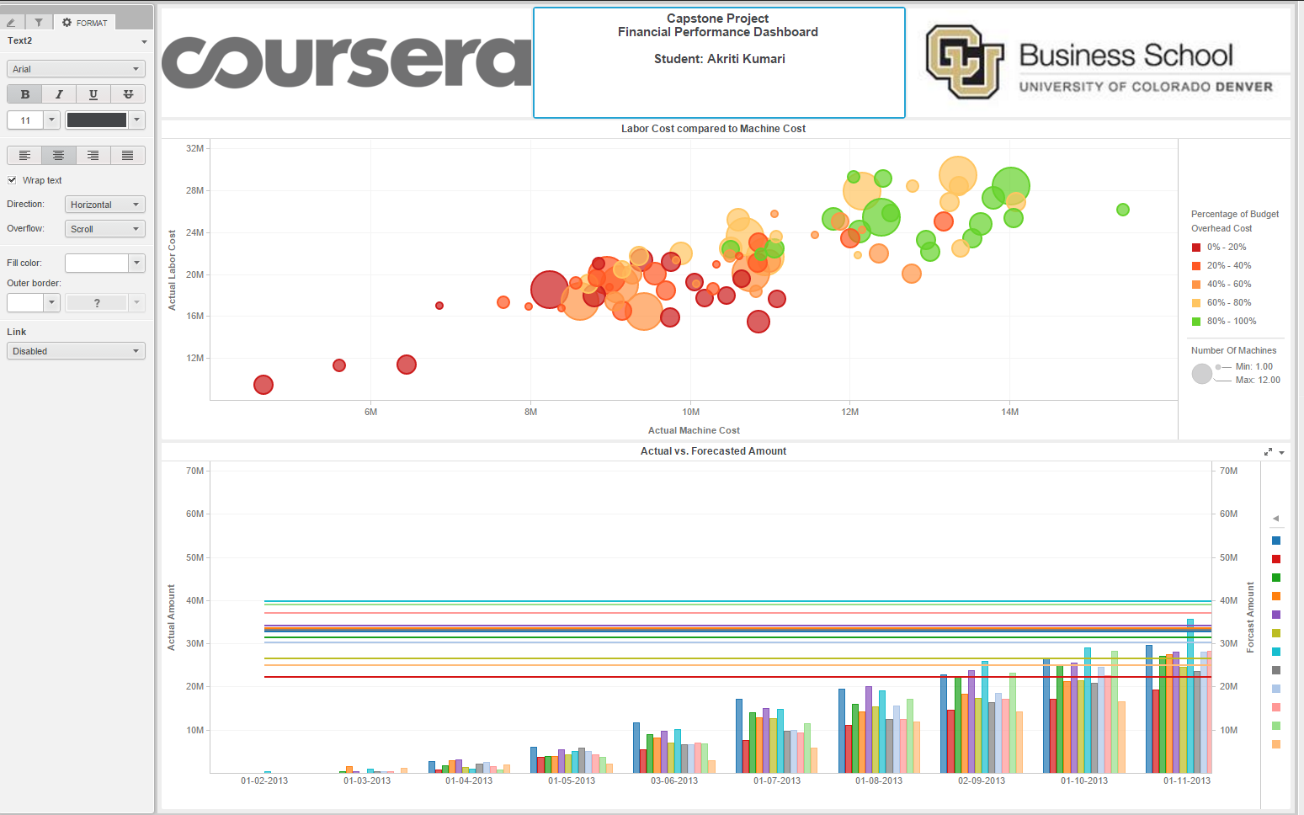

* Labor Cost Comapred to Machine Cost:- it helps to identify how the budget overhead cost compares in relation to the Actual machine cost and Actual labor cost. Red shows the lowest budget overhead cost and the ones in green show higher overhead budget cost.

Analysis :- Chicago has the highest machine cost and labor cost for the machine type Model 202.

Denver seems to have lowest budgeted overhead cost.

Chicago is seen to have highest forecast amount in the year 2014.